Module 4 - Test driven development and Logging framework
SL4J Logging exercises

Exercise 1: Logging Error Messages and Warning Levels
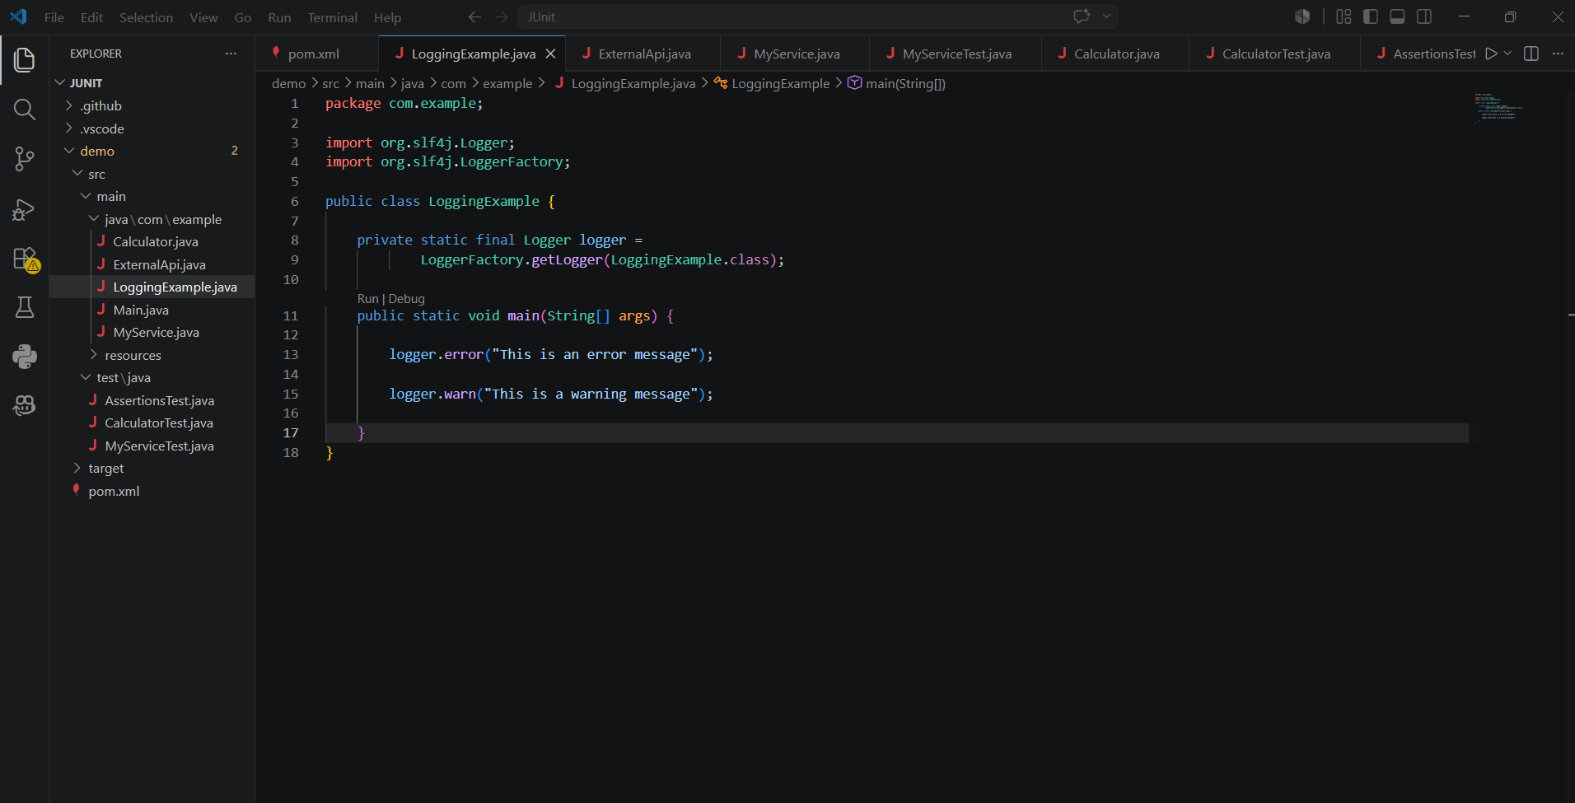

Output
